OYO BOOKING ANALYSIS

# CREATING DATABASE:

1. Click **New Query** in the toolbar.

CREATE DATABASE HotelBookingAnalysis;

Use HotelBookingAnalysis

1. Refresh the Databases node to view your new database.

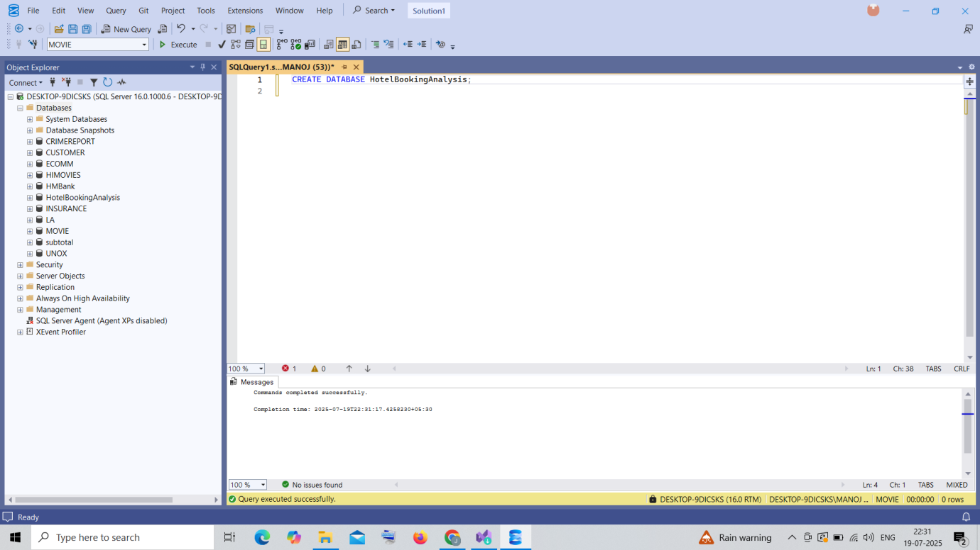

# 2.IMPORTING DATA:

1. Save your Excel files as CSV
2. In SSMS, right click your database, go to tasks, and import data

(or) change the file into CSV and then import flatfile

